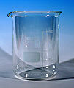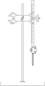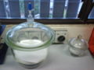

Beaker Buret on Butterfly clamp Desiccator

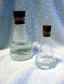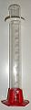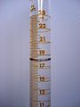

Erlenmayer Flasks Graduated cylinder Meniscus surface of water
with stoppers in a graduated cylinder

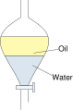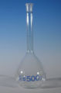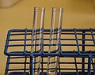

Separatory Funnel Volumetric Flask Test tubes on a rack

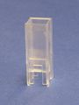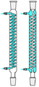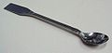

Cuvette Condenser Spetula

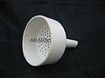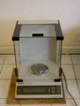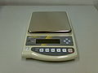

Buchner Funnel Analytical balance Electronic balance
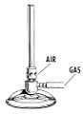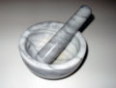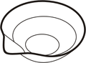

Bunsen burner Mortar and pestle Evaporation dish

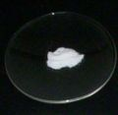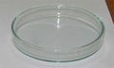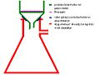

Watch glass Petri dish Suction setup

